

Research Manual

Powerlifting app using Movesense wearable technology

**Student Name: Samuel Orekoya**

**Course Name: BSc (Hons) in Software Development**

**Student ID: C00215885**

**Supervisor: Joseph Kehoe**

**Submission Date: 01/11/2019**

# Abstract

This document/manual will outline the research which will be taken in the creation and of the development of a fitness/strength related mobile application using Movesense Technology. With this document it will provide a written account of the research done in creating the powerlifting app “Power Athlon”. This application will improve strength training for a number of sports athletes but in particular powerlifters. With this application a user will be able to see his acceleration, speed and power of a user’s 3 main lifts. The squat, bench and deadlift these are the 3 main compound lifts, these lifts our also the 3 lift that would be tested in a powerlifting meet.

The research done will cover already existing applications or even similar applications with similar functionalities of the one that is being developed. This document will also cover technologies which could be used as well. This application will be suitable for any user with any level of strength training. The information that will be provided from the application will also be extremely useful for elite athletes. As this can show valuable information to their coaches which can help them see where improvements in training can be made. As they will have an accurate information on their strength training.

Table of Contents

1. Abstract 1

2. Introduction 3

3. Powerlifting 4

3.1 Strong Man 7

3.2 CrossFit 7

4. Existing Applications and Technologies 8

4.1 Beast Athlete Motion Sensor Gym 8

4.2 Fitbit Charge 3 Heart Rate 10

4.3 Strenx Gymwatch 13

5. Wearable Technology Market 14

5.1 IOT 14

5.2 Movesense 15

5.2.1 Movesense Sensor 15

5.3 Totem Open Health 16

5.4 FitBit 16

5.5 Suunto 17

5.6 Garmin 17

6. Technologies 18

6.1 Front end 18

6.1.1 Xamarin 18

6.2 Back end 19

6.2.1 Python 20

6.2.2 C++ 20

6.2.3 Java 20

6.1.1 MySQL 20

6.1.2 NoSQL 21

6.3 Cloud infrastructure 21

6.3.1 AWS 21

6.3.2 Google cloud platform 22

6.3.3 Python Anywhere 22

6.3.4 Microsoft Azure 22

6.3.5 Oracle Cloud 23

7. Conclusion 24

8. References & Fig 25

# Introduction

The purpose of this manual is to document and detail all the research that will be done for this project. The aim of this project is to create an application to help athletes or users that wish to improve their strength training by analysing their main lifts and displaying valuable information like speed and power.

As this project will be great use for strength athletes and in particular powerlifters. Powerlifting as a whole will be researched in-depth while briefly going into similar strength training styles like strong man and CrossFit. Fitness will also be touched on as well and how reps and sets work.

Research on existing application will be a big part of this research document. A good amount similar application will be reviews and broken down into what the application did well and what they don’t do so well. With the information that will be achieve from these reviews. This will in turn help while trying to develop an application that customers will want. Applications that will be reviewed/researched will be Beast Athlete Motion Sensor Gym, Fitbit Charge 2 Heart Rate and Strenx Gymwatch . The main research will be done on the power and strength application for in particular powerlifters and crossfitters as they will be more simlair to the application that will be created. Beast Athlete Motion Sensor Gym and Strenx Gymwatch will be the two application that would be the most similar to Power Athlon.

As wearable technology will pay a large part in this project lots of research will be done on it. The reviews that will be done will be more tech based then application based. One of the best ways of reviews these technologies will be by using website reviews, video review and reading documentation on hardware.

Movesense wearable will be the wearable technology that will be used in this application so lots of research on the hardware will be done. Research on the firmware being used and how it works will be done. Research on how developers will integrate this firmware with the software they have created. Lots of movesense projects will be researched to see what mistakes were made and how they were resolved throughout the development part of the project.

The technologies that will be used in the development part of this project is very important this will in turn structure the way the app will be developed. The front- end technologies will be discussed in this document and back-end technologies like C++, Java, Python and Xarmin. The other back-end technologies that will be discussed will be MySQL and NoSQL. There will also be a discussion about if the application should be server based or cloud base using technologies like AWS, Google cloud platform, Python anywhere, Oracle Cloud and Microsoft Azure. With all the possible technologies that could be used I will talk in-depth about each then pick the best technologies that would suit my skill sets and my goals for the project.

# Powerlifting

Powerlifting is a strength sport exercise that consist of three attempts at maximal weight on the three main lifts squat, bench press and deadlift. Like the Olympic weightlifting it involves the athlete attempting a max weight single lift of a barbell loaded with weighted plates. [5] Powerlifting originated from a sport known as odd lifts which followed the same three-attempt format but used a wider variety of events kind of like the strongman competition. Eventually odd lifts became standardized to the current three. The first competition was in the early 20th century in the US. In competition lifts may be performed with or without equipment typically referred to as raw or classic. The International Powerlifting Federation (IPF) was formed immediately after the contest so none of the lifts could be yet registered as official world records. [5] The 1973 Worlds was also held in York. This time there were only 47 entrants. One Swedish, one Puerto Rican Peter Fiore for Zambia, two Canadians, one West Indian, eight British, and the rest Americans. Bob Crist was the first IPF President and Clarence Johnson was the first Vice-President. 1973 was the first time that the lifts were done in the order now recognized – squat, bench press, deadlift

In powerlifting there are multiple weight classes within 3 age categories. [5] Most of these figures depend on the federation athlete is competing in. [30]

**Age categories**

* 15-18 (Sub-Jr)
* 19-23 (Jr)
* Any age (Open)
* 40+(Masters)

**Weight Classes (Men)**

* 52 kg
* 56 kg
* 60 kg
* 67.5 kg
* 75 kg
* 82.5 kg
* 90 kg
* 100 kg
* 110 kg
* 125 kg
* 140 kg
* 140 kg+

**Weight Classes (women)**

* 44 kg
* 48 kg
* 52 kg
* 56 kg
* 60 kg
* 67.5 kg
* 75 kg
* 82.5 kg
* 90 kg
* 90 kg+

**IPF Weight Classes (Men)**

* up to 53 kg (Sub-Junior/Junior)
* 59 kg
* 66 kg
* 74 kg
* 83 kg
* 93 kg
* 105 kg
* 120 kg
* 120 kg+

**IPF Weight Classes Women)**

* up to 43 kg (Sub-Junior/Junior)
* 47 kg
* 52 kg
* 57 kg
* 63 kg
* 72 kg
* 84 kg
* 84 kg+

**Competition and events**

In a powerlifting competition competitor are allowed 3 attempts on each lift squat, bench press and deadlift depending on their standing and the organization they are lifting in. [31] The lifter's heaviest valid attempt on each lift counts toward the competition total. For every weight class the lifter with the highest total wins. In many meets the lifter with the biggest total relative to their weight class also wins. [31] If two or more lifters achieve the same total the lighter lifter is ranks above the heavier lifter. Competitors are judged against lifter of the same age and weight class. This helps to make sure accomplishments like lifters like Lamar Gant who has deadlifted 5 times his body weight and Ray Williams all-time raw world record holder in the squat and deadlift are recognized alongside greats like Eddie hall who has the current All-time deadlift world record. [31]

A standard competition is where there are three events the bench press, squat, and deadlift. [31] Placing is achieved by combined total of all lifts. Some variations of this are found at some meets such as push-pull only meets where lifters only compete in the bench press and deadlift. Where the bench press coming first and the deadlift after. [31] There are also single lift meets or full meets where sometimes alongside a normal 3-lift event. The order of a traditional meet goes squat, then bench press and the deadlift.

**Rules**

A lifter would get there wanted position before un-racking the weight in either the bench press or squat. After un-racking the lifter would set their position again then wait in this position for the head referee's signal. [32] The signal will be given as soon as the lifter is fully set and demonstrates control of the bar with the bar properly positioned. The head referee's signal shall consist of a downward movement of the arm and audible command “Squat” or “Press”. In the squat lifters most be squated fully parallel to the ground and the weight most not move back down after the squat command. While in the bench after the press command the weight also most not move back down, or lifts will be disqualified. [32] As soon as the lifter demonstrates total control at the end position. The head referee will give the signal indicating completion of the lift and to replace the bar also known as un-racking the bar. In the deadlift it is a bit different the bar is laid horizontally in front of the lifter’s feet. Lifter must grip onto the bar and lift until the lifter is standing up straight. The bar may stop/stall but there must be no downward motion of the bar like in the bench and squat. [32] When the lifter gets set in his or her position and starts to pull once up straight the head referee's signal shall consist of a downward movement of the arm and the audible command "Down". The signal will not be given until the bar is held totally motionless and the lifter is in an apparent finished position at the top of the deadlift. [32]

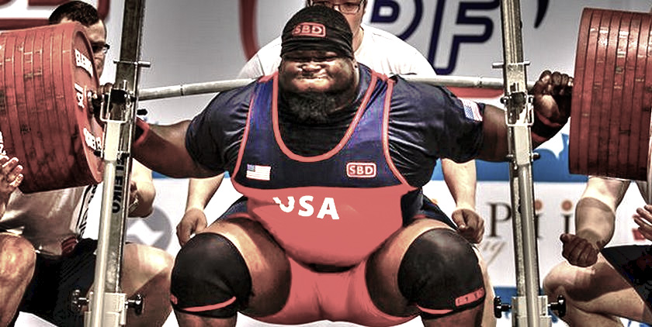

Fig [3] Ray Williams

This image shows one of the elites Ray William performing a squat at IPF worlds

**Training**

In powerlifting lifters practice weight training to improve performance in the three competitive lifts the squat, bench and deadlift. Weight training routines used in powerlifting are very varied. Some training types look for the use of many variations on the contest lifts like block pulls and block presses. [5] While others look for a more limited selection of exercises and an emphasis on mastering the contest lifts through repetition. Powerlifters training differs from bodybuilding with less focus on volume and hypertrophy and more focus on power generation than weightlifting. [5] Powerlifters sets and reps are based on a percentage of the lifter's (1RM) one rep maximum. 5 sets of 5 reps (5x5) at 75% of the 1RM is a very common training structure in powerlifting training. Rest periods between sets range from 4–7 minutes based on the lifter's ability to recover fully for the next set. [5]

**Federations**

The main international powerlifting federations.

* World RAW Powerlifting Federation (WRPF)
* 100% Raw Powerlifting Federation
* Global Powerlifting Committee (GPC)
* Global Powerlifting Federation (GPF)
* International Powerlifting Federation (IPF)
* International Powerlifting League (IPL)
* Natural Athlete Strength Association (NASA)
* World Drug-Free Powerlifting Federation (WDFPF)
* World Natural Powerlifting Federation (WNPF)
* World Powerlifting Alliance (WPA) (Founded 1987)
* World Powerlifting Congress (WPC)
* World Powerlifting Federation (WPF)
* World United Amateur Powerlifting (WUAP)

## Strong Man

Strong man is a sport which tests athlete’s strength in a variety of non-traditional ways. Some of these disciplines are very alike to powerlifting and some powerlifters have also competed in strong man games. [6] Strong man training events also test an athlete’s physical endurance to a degree which isn’t found in powerlifting or other strength-based sports. [6] Such as carrying heavy refrigerators, flipping truck tires, and pulling vehicles with a rope. Strong man competitions are made to test the strength of participants like how they use to be tested in the pre-date history. The Highland games in Scotland are often said to be the first strongman competitions. Strongman competitions like World's Strongest Man started to become popular and televised in the 1970s. [6]

**Common disciplines**

There are no set rules on what specific game will occur in a contest. In a contest there will never be 2 squat event, 2 overhead lifting event. [6] In a normal contest 6 event are done but in compitions with top compieters 7 or 8 games maybe done. Here are the 8 events that are done in these games.

* Farmers walk
* Hercules hold / Pillars of Hercules
* Vehicle pull
* Atlas stone
* Stone carry
* Refrigerator carry
* Carry and drag
* Fingal’s finger

## CrossFit

CrossFit is a new fitness regimen created in 2000 by Greg glassman in California. [7] CrossFit is endorsed as both a physical exercise philosophy and a competitive fitness sport, incorporating elements from high-intensity interval training (HIT), Olympic weightlifting, plyometrics, powerlifting, gymnastics, girevoy sport, calisthenics, strongman, and other exercises. In the US CrossFit is practiced the most and by individuals who complete daily workouts otherwise known as “WODS” or “workouts of the day”. [7]

CrossFit is a strength and conditioning program which consist mainly of a mix of aerobic exercise, calisthenics and Olympic weightlifting. [7] Hour long classes at affiliated gyms/ boxes typically include a warm-up, a skill development segment and a high intensity the WOD. Then a period of individual or group stretching. [7]

Some boxes also often have a strength-focused movement prior to the WOD. [7] Performance on each WOD is often scored and ranked to encourage competition and to track individual progress among crossfiters. Some gyms offer additional classes such as Olympic weightlifting which are not centered around a WOD.[7]

CrossFit gyms use multiple equipment from multiple disciplines like barbells, dumbbells, gymnastics rings, rope climbs, pull-up bars, jump ropes, kettlebells, medicine balls, plyo boxes, resistance bands, rowing machines, and various mats. CrossFit is focused on constantly varied high-intensity and functional movement. This draws on categories and exercises such as calisthenics, Olympic-style weightlifting, powerlifting, Strongman-type events, plyometrics, body weight exercises, indoor rowing, aerobic exercise, running, and swimming. [7]

# Existing Applications and Technologies

While researching existing applications, I wasn’t able to get my hands on any physical wearbles but research and reviews will help on this section. This will help me to understand how some of the features work and will help me create a brilliant user experience. The below applications will be researched and reviewed.

## Beast Athlete Motion Sensor Gym

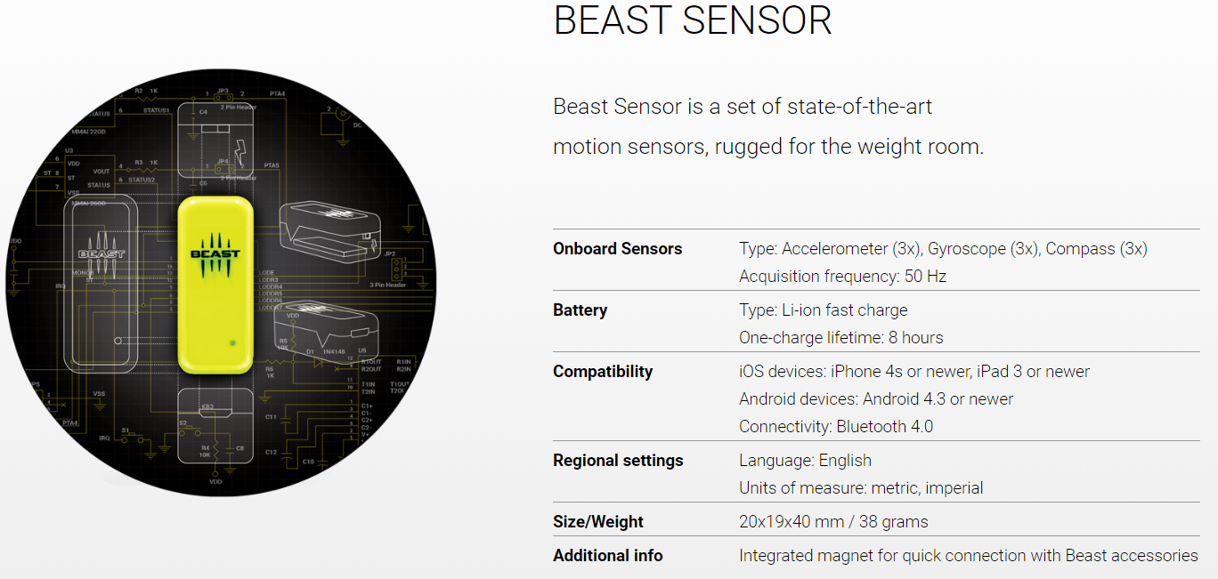

Fig [7] Beast Sensor

This image displays the Beast sensors hardware details

The Beast enables tracking the greatest amount of exercises. Being magnetic beast is compatible with a variety of different weights, machines and supports bodyweight exercises too. [27] This is a very important feature and really standout to it competitor as you can attach the sensors to machines not just a user waist or arm. Beast sensor transfers data about strength, power or speed for each lift on your smartphone or tablet in real-time in to help give you the best training session possible.[27]

Users can review their performance in detail during rest time in between sets. Beast will give suggestions from Beast and improve training adjusting loads, sets or reps based on your training goal.[27] With the Web Portal it collects all data received from the Beast App which has a IOS and Android version and stores your performance-based training in a diary. It will also review your performance, Plan & manage your training cycles, compare training data and Create custom exercises and routines. [27]

Lots of Video Tutorials are provided on thisisbeast.com and on YouTube. A list of review done and the application is also on the website with review from Forbes, Gadgetsandwearables and Shapefit.

**Price Ranges of beast Products**

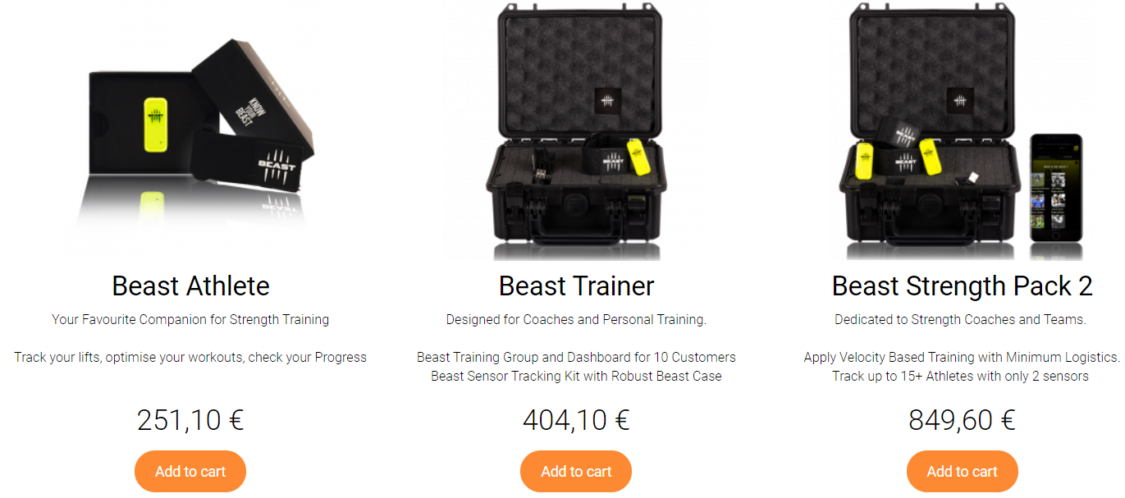

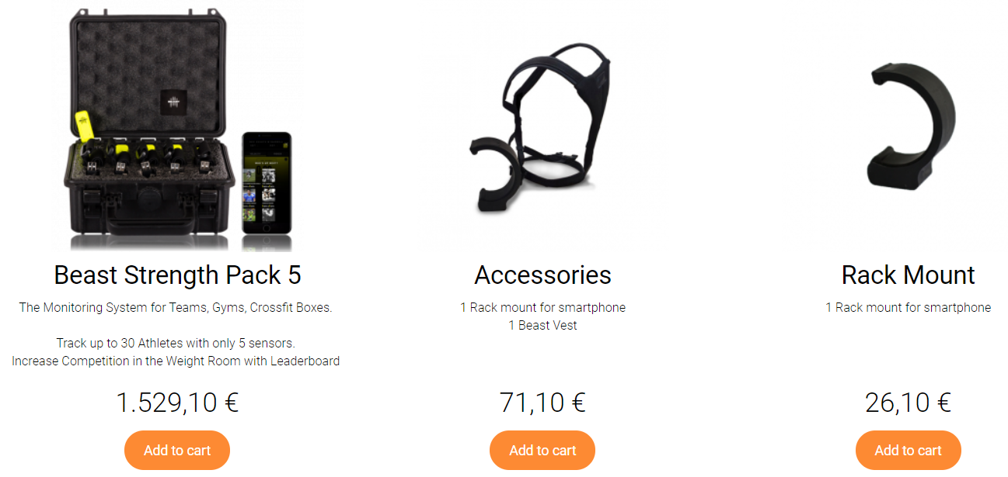

Fig [7] Beast Sensor prices

This image displays all the types of accessories available

The tech reviews that will be review will be Beast Sensor - Weight Lifting REVIEW by Techy Agent.

**Review pro and cons**

**Pro**

* Sensor can be attached to weight and machine allows for more accuracy.
* List of workouts and what type of training you want to achieve during workout.
* Gives a power score
* Easy to use and has a simple but efficient UI.
* There is an option to change metrices like pounds to kg.
* You can create new exercises that are not on the provided list.

**Cons**

* Set up time will add approx. 15-20 mins on to your workout.
* Accessories vest Is needed to perform some movements like squat and press up accurately.
* No history displayed on app users will have to login to the web application to review history.

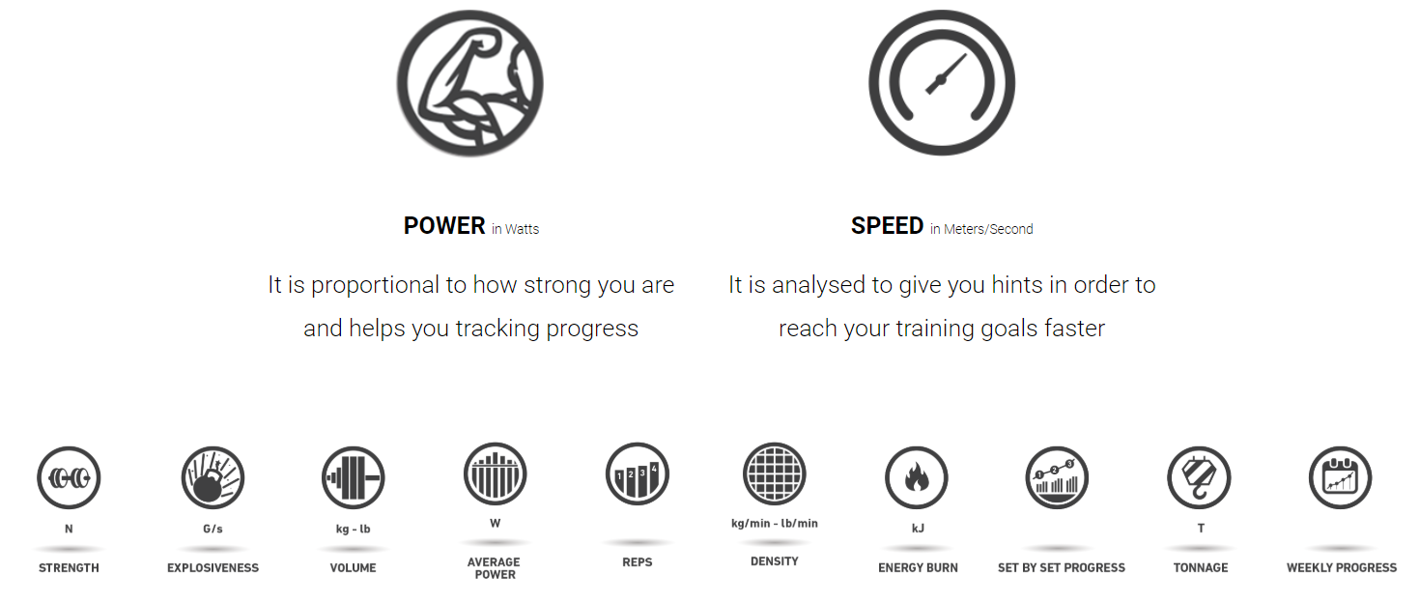

Fig [7] Beast Sensor measurements

This image displays all the types of data that is measured

## Fitbit Charge 3 Heart Rate

The fit bit charge 3 is the new and improved version of the Fitbit Charge 2. The Fitbit Charge series is one of the world’s most popular wearables and is Fitbits best-selling tracker with apps on IOS and Android. With a very basic interchangeable accessory band and a large OLED screen.[28] The Fitbit is more then use a fitness wearable that counts you’re step or show you how many calories you have brunt in a day. Here are some of the Feature that come with the Fitbit Charge 3.[28]

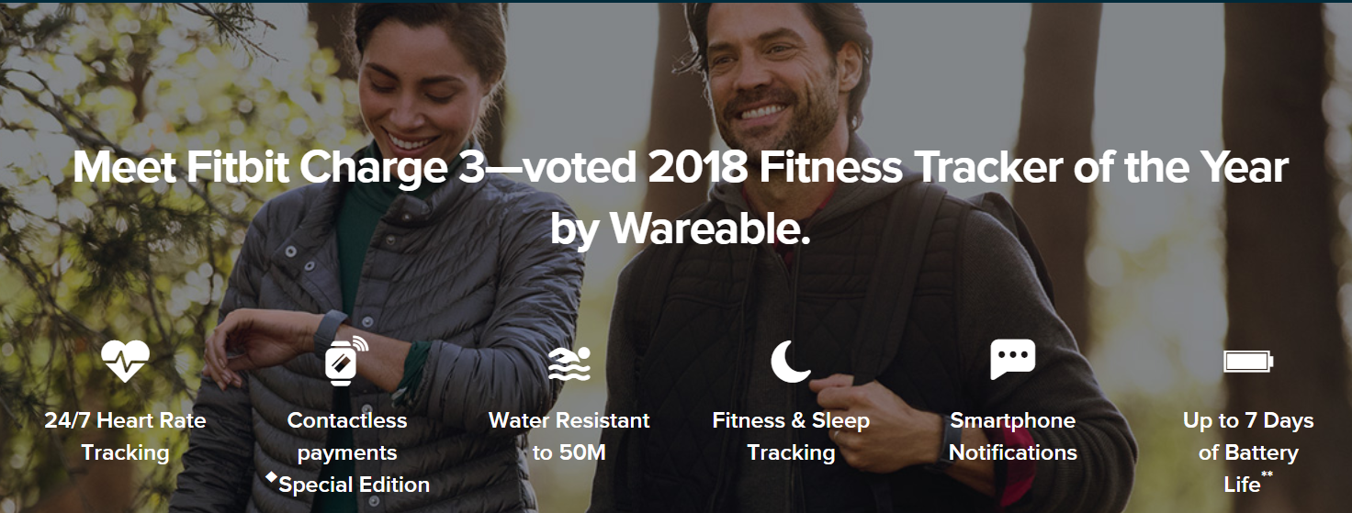

Fig [8] Fitbit Charge 3

This image displays the main functionality of the Fitbit Charge3

**24/7 Heart Rate**

Charge 3 uses Fitbits most advanced heart rate sensors and algorithms to uncover insights on your heart and its health.

**All Day Calorie Burn**

Know how many calories you’re really burning all day to reach your goals.

**Real-Time Heart Rate Zones**

See when you’re in Fat Burning, Cardio or Peak zones to make the most of every workout.

**Auto Sleep Tracking**

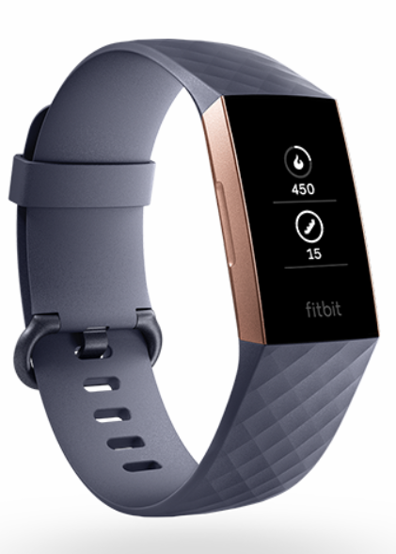See how long you’re in light, deep and REM sleep and get personalised insights on how to rest better.

**Female Health Tracking**

With the Fitbit Charge 3 alongside the Fitbit app female users can track periods, record symptoms and estimate ovulation and fertility windows.

**Fitbit App Dashboard**

Set goals and connect with friends and get a snapshot of your health and fitness all in one place.

**Automatic Exercise Recognition**

Exercises like runs, swims, sports and more are automatically recorded for you with SmartTrack.

**Over 15 Goal-Based Exercises**

Choose from run, bike, swim, yoga, circuit training and more, then set a goal and get real-time analysis.

**Real-time Pace and Distance**

Connect Charge 3 with your phone's GPS to see pace and distance Fig [8] Fitbit Charge 3

**Water Resistant to 50M**

Charge 3 is now water-resistant up to 50M so you can track time in the pool.

**Reminders to Move**

You will get a nudge that you need to move if you’ve been sitting for too long.

**Personalised Guided Breathing**

Available breathing sessions based on your heart rate. [28]

**Smart Experiences**

With Fitbit Charge 3, everyday smart experiences like calendar and weather are just a tap away.

**Notifications & Quick Replies**

Get call, calendar, text and smartphone app alerts. Plus send quick replies to messages on Android.

**Fitbit Pay**

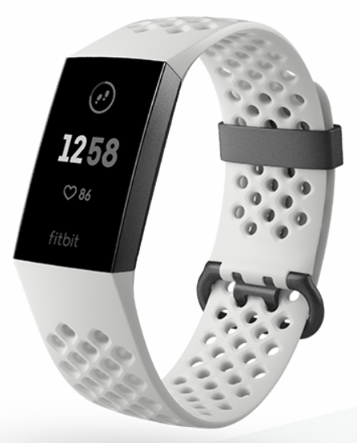Add your credit cards to the Fitbit app, then use Fitbit Pay to make easy, secure payments on-the-go.

**7 Day Battery**

A multi-day battery life provides insights and inspiration coming day and night.

**Smarter, Sharper Touchscreen**

The back-lit display automatically adjusts to lighting conditions so you can easily see info at any time of the day.

**Durable, Lightweight Design**

With aerospace-grade aluminium, a smooth-flush case and Corning Gorilla Glass 3. [28]

Fig [8] Fitbit Charge 3

The tech reviews that will be review will be Fitbit Charge 2 - Fitness REVIEW !!! by Techy Agent.

**Review pro and cons**

**Pro**

* Very accurate in sensing heart rate.
* very accurate in gym actives.
* Does all the simple jobs great.
* Build quality is great.
* Touch screen works very well with a great UI.

**Cons**

* A bit slow in displaying heart rate compared to competitors (apple).
* Heart rate doesn’t display while swimming.
* You have to bring your phone with you if you want to track GPS.

## Strenx Gymwatch

GymWatch is one of the top fitness tracking apps on the market. This wearable is built for gym goers specifically people that only train with weights. This technology is worn on the arm or leg. [29] This app was created to help build muscle and making sure you're completing your reps and sets properly. [29]

Gymwatch use a new motion sensors technology, an accelerometer, gyroscope and magnetometer in a slightly different way to Fitbits. [29] When all the features are put together it allows user to be able to track the course of limb movements and measure the tension in different muscle contractions.

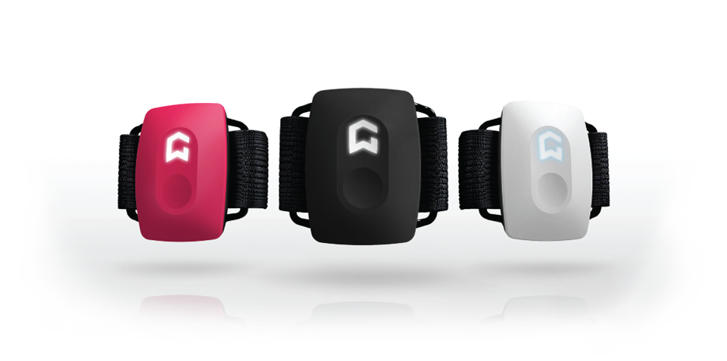This hardware can learn what exercises you're performing and analyze if you’re doing them properly or not in real time. [29] That data is sent via Bluetooth to the GymWatch app. This technology works with all types of weight and all types of machines. If users put on multiple sensors at the same full body workouts will be tracked with great accuracy. [29]

Fig [9] Gymwatch

This image displays the Gymwatch in its 3 colours pink, black and white

The tech reviews that will be review will be GYMWATCH - Hands On REVIEW by Techy Agent.

**Review pro and cons**

**Pro**

* Light and compact with great design.
* Voice coaching can be very help.
* Get accuracy when counting reps.
* Applications Ul is brilliant.

**Cons**

* Some workout could not be tracked like jump rope and come CrossFit exercises.
* Very time-consuming Set up time will add approx. 15-20 mins on to your workout.
* Real time coaching can be very annoying at times.
* IPhone app compatibility not the best.

# Wearable Technology Market

Wearable technology is when electronics devices which can be worn on the body in the form of clothing or accessories like watches. [1] This technology can collect information to improve the user’s natural abilities. The world’s top wearable technology companies are now offering numerous of wearable technology products like fitness trackers, smart watches, smart clothing, head mounted displays, smart jewellery, and implantables. The sensors in wearable tech devices records and analyses wearer’s data in real time and provides valuable insights related to the user’s activities, fitness and in my case strength.[1] Some wearable devices such as VR headsets and smart glasses also provide virtual and augmented reality experience to the users. [1]

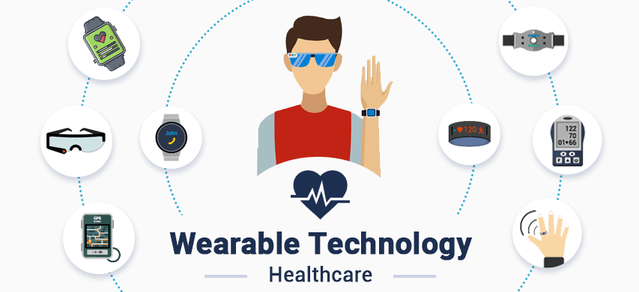

Fig [1] Wearable Technology Healthcare

This image shows all sort of wearable technologies

## IOT

IOT devices like wearable technology devices are gaining popularity among medical, automotive and the consumer industries. These IOT device can connect to the internet and exchange data among the device and the network. [1] While in turn helps in resolving some supply chain issues for end user’s industries by Improving their decision-making process. This will mean that the increasing preference for a connected environment and the need to access real time data is driving the wearable technology market growth during the coming years. [1]

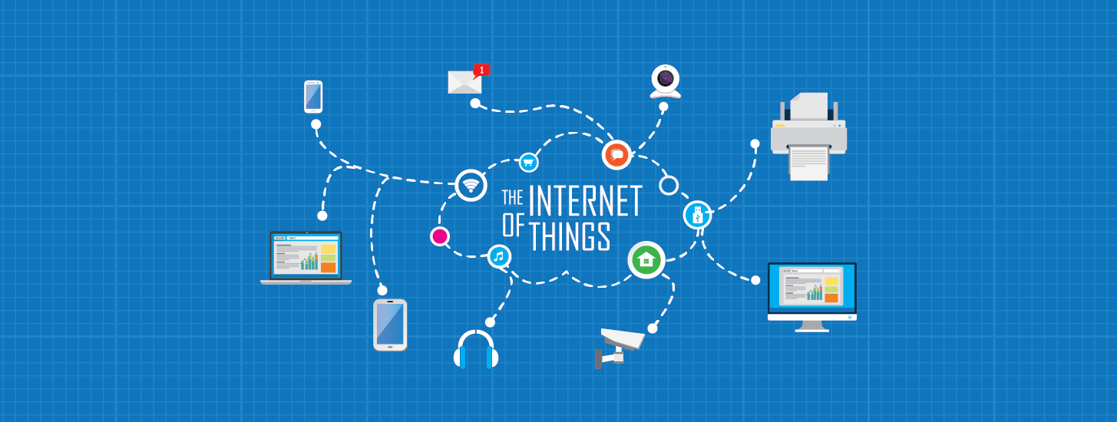

Fig [2] IOT

This image shows how the internet of things work

The main market that wearable tech is increasing in is healthcare industry. [1] Wearable device manufacturers are constantly trying to improve and focus on the development of specialized wearables for the healthcare sector. This will in turn allow doctors to collect patient’s data easily leading to advanced diagnosis. [1] The integration of haptic technology (tactile feedback technology) in smart watches will be another important trend that will drive the growth within the up and coming years. [1]

## Movesense

Movesense is one of the best open development platforms for motion sensing and biometrics and will be the used and integrated within Power Athlon. [2] It is an easy and innovative tool allowing developers to build their own wearable device quickly and cost-efficiently. [2] With this technology you can track sports, health, equipment and machinery so anything that moves. This was company was created by the Finnish sports watch expert Suunto. [2]

### Movesense Sensor

The Sensor from Movesense our Versatile, light and small but extremely durable sensor capable of measuring any movement and much more. [2] Very customizable functionality through open APIs that enable development of unique in-device application. The functionality can easily be tailored to fit the exact needs of the target use case.[2]

* Swim and shock proof construction suitable for any sports.
* User replaceable coin cell battery.
* State of the art ultra-low power components.
* Small in size and light in weight.
* Available with custom branding.

**Technical highlights**

* 9-axis motion sensor: acceleration, gyroscope, magnetometer.
* Heart rate, R-R- intervals, BLE heart rate service, optional: single channel ECG.
* Tools for developing customized applications that run inside the sensor.
* Software libraries for developing compatible mobile applications.
* 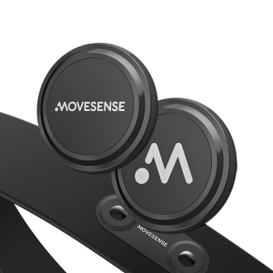iOS and Android mobile libraries with wireless sensor firmware update capability.
* Wireless firmware update capability.
* Easy to use C++ Movesense Device API.
* Bluetooth® 4.0 radio.
* Temperature.

## Totem Open Health

Totem Open Health is another open platform and ecosystem for wearable health technology. Ecosystem includes sensors, data collection, storage, sharing and analysis and algorithmic interpretation. [3] With the open nature of Totem Open Health provides opportunities beyond what is currently possible in proprietary shut solutions. Such as unhindered collaboration, faster innovation, localized development, addressing of low-volume niche problem areas, transparency and shared knowledge for the benefit of all. [3]

Totem Open Health are currently developing the first product for the Open Health ecosystem. The Totem Health Patch is a cost effective, completely open sourced. Small wearable device containing great sensors, packaged in robust casings, flexible to be applied in many contexts and circumstances.[3]

Along with the development of the Totem Health Patch development of solutions for data storage, analysis and algorithm development and sharing. [3]

**Technical highlights**

* 3-axis accelerometer and gyroscope.
* Temperature.
* Raw data on MicroSD.
* Bluetooth low energy.
* Battery up to 40 days.
* 100Hz sampling frequency.
* Compact form factor.

## FitBit

Fitbit is one of the world’s largest health tracking smartwatches. Fitbit Inc is an American company founded in 2007. [33] The products Fitbit creates are activity trackers, wireless-enabled wearable technology devices that measure number of steps walked, heart rate, quality of sleep, steps climbed, and other personal metrics involved in fitness. [4] Before October 2007 the company was previously named Healthy Metrics Research Inc. Some evidence has found that the use of similar devices results in less weight loss rather than more.

Fitbit also offer website and mobile app for IOS, Android and window 10. [34] Trackers are synced to device such as mobile phone via Bluetooth. Last year the Fitbit charge 3 won tracker of the year by Wearable. Amazon Alexa is also integrated into the new Versa 2 smartwatch. Fitbit offer 7 smart watches the Ace2, Inspire, Inspire HR, Charge 3, Ionic, Versa Lite Edition and Versa 2. [4]

Every Fitbit device includes a variety of sensors that have been exposed through the Sensor APIs.

**Technical highlights**

* Accelerometer.
* Heart Rate.
* Barometer.
* Orientation.
* Gyroscope.

## Suunto

Suunto is a Finnish company that produce measuring instruments and market sports watches, dive computers, compasses and precision instruments. [8] Headquarters are in Vantaa in Finland the company was founded in 1936. Suunto produce up to 15 smart watches ranging from €169 - €700. Suunto’s application is very user friendly and displays added information from the smart watches available. [9]

**Key features**

* View training, activity and sleep summaries.
* View overall trends to help keep your life in balance.
* Stay connected with notifications.
* Customize your own sport modes on your watch.
* Activity-specific heatmaps in Suunto app show you where the most popular routes are, all around the world.
* For Suunto 3 Fitness shows your speed and distance as well as your track in the map by using the Suunto app GPS from your mobile phone.
* With Suunto D5, Suunto EON Steel, Suunto EON Core you can transfer your dive logs easily over Bluetooth to your mobile phone after diving.
* Connect to your favourite sports services, such as Strava, Endomondo, TrainingPeaks, Relive and more.

## Garmin

Garmin also known as ProNav is an American multinational technology company founded in 1989 by Gary Burrell and Min Kao in Lenexa Kansas. [10] Since 2010 the company is incorporated in Schaffhausen Switzerland. The company Garmin specializes in GPS technology for automotive, aviation, marine, outdoor and sport activities. Due to their large development in wearable technology they have also been competing with activity tracker and smartwatch consumer developers such as Fitbit, Suunto and Apple.

Within the Garmin range there are up too 35 wearable technology watches price ranging from £2249 - £69. [11]

**Key features for high end smart watches**

* Lap time repeatability.
* Electronic tachymeter.
* Smart notifications.
* Music apps.
* Garmin pay.
* Stress score.
* Pulse Ox (bodys oxygen levels).
* Performance metrics.
* Multi-GNSS.
* TopoActive Europe and ski maps.
* Battery (28 hours in GPS mode, 48 hours in UltraTrac).

# Technologies

This section of the research manual will explore all the possible technologies and development tools that could be used to build the application. In this section research will be done to see what has already been used to develop similar application and to see what technologies would be suited to be used. The aim for this project is an application that can taking data from the movesense sensors and with that data displays important like how fast an athlete has moved a weight. Also allowing users to input certain variables like weight to help narrow down results. In this application will use C++ to get receive the data from the sensors then Xamarin to make it cross platform.

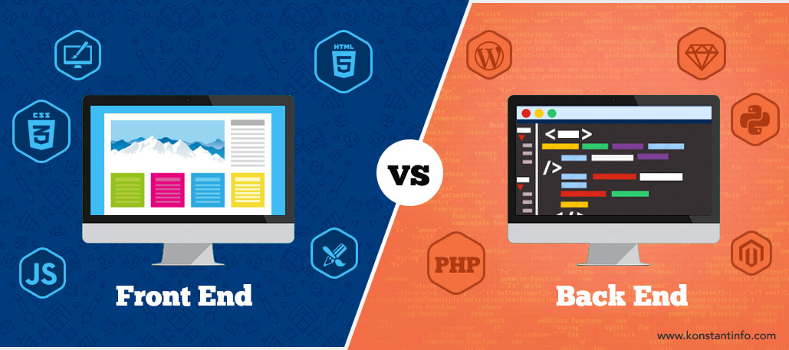

Fig [6] Front end vs Back end

This image displays the differences between front end and back end.

## Front end

The technologies in the front end are constantly on display from the users these technologies work on making the application display data to the screen. The technologies like the program language and web frameworks like HTML, CSS, and JavaScript.

### Xamarin

Xamarin is a free and open source Microsoft-owned company which was founded in 2011 in San Francisco. Xamarin was created to make enable the development of cross-platform application using a shared C# code base. [12] Xamarin can be used on all platform with a native interface. There is also a large amount of resources available to Xamarin developers on the web. Visual Studio also includes Xamarin to be used by developer. [12] With Xamarin developers only need to create one application that can be run on each target system. Xamarin provides SDK access for iOS, Android and Windows which is not the case when creating using other frontend platforms HTML and JavaScript. [13]

Xamarin also gives various technologies for the development of applications.

* Xamarin.Forms
* Xamarin Test Cloud
* Xamarin.Mac
* .NET mobility scanner

In Xamarin 3 a new product feature was created that allows one to use portable controls subsets that are mapped to native controls of Android, iOS and Windows Phone.

Xamarin test cloud creates a way to test mobile apps written in any language on real for non-jailbroken devices in the cloud. Xamarin test cloud uses object-based UI testing to easily simulate real user interactions. [12]

Xamarin.Mac was development as a tool for Apple technology application developed in the C#. Xamarin.Mac as well as Xamarin.iOS and Xamarin.Android gives developers up to 90% of code reuse across Android, iOS and Windows. Xamarin.Mac gives C# developers the ability to build fully native Cocoa applications for the mac OS and allows for native apps that can be put into the Mac App Store. [12]

Xamarin.NET Mobility Scanner is a free web-based service using Silverlight. Xamarin's .NET Mobility Scanner it allows developers to see how much of their .NET code can run on other operating systems as specifically Android, iOS, Windows Phone, and Windows Store. [12]

At a low level, Xamarin will converts the entire existing Android and iOS SDK to C# so that developers can code in language that they are more confident in like C#. [13] But user’s interfaces must be built separately and must then be connected to the codebase. The Xamarin component store lets you add more functionality to your applications by simply downloading some plugins.[13] You can easily integrate your application with many popular backends such as Microsoft Azure if a user wishes to.

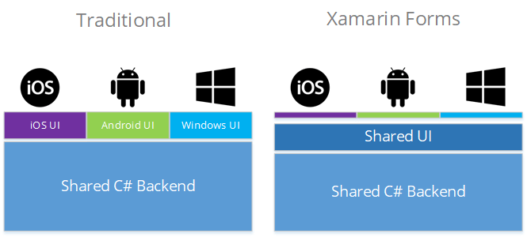

Fig [4] Xamarin

This image shows how Xamarin form are cross platform as they share UI

## Back end

The technologies in the back end are always hidden from the users these technologies constantly work in the background. The technologies like the program language and web frameworks like Python, java and C++.

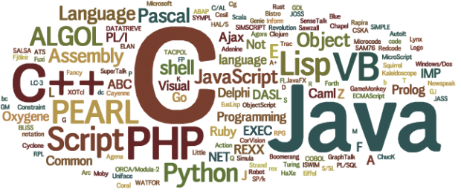

Fig [5] Programming languages

This image displays lots of common programming languages and some of which will be discussed below.

### Python

Python is an object oriented, high level programing language that is interpreted and dynamic semantics. [14] Pythons high-level built-in data analysists mixed with dynamic typing and dynamic binding make it very attractive and a fan favorite for rapid application development. [14] As well as python being simple easy to learn syntax highlight readability which in turns reduces the cost of program maintenance. [14] Python also have a large amount of support modules, libraries and packages to help developers having to always re-invent the wheel.

### C++

In this project I will be using C++ to retrieve all the data from the Movesense sensors. [15] C++ is one of the largest general-purpose programming languages created in the 1985 by Bjarne Stroustrup as an extension of the C programming language. The language has expanded significantly over the last 20 years and modern C++ has object-oriented, generic and functional features. [16] It is always implemented as a compiled language and many vendors provide C++ compilers making it available on many platforms.

### Java

Java is one of the most widely used programming languages in the world used by millions and millions. [17] The keys feature of Java is having Object Oriented Programming built in, Open

Source Libraries, APIs, Strong community support and many IDEs with powerful error-checking

capabilities. Java code can run on near to all platforms that support Java without the need for recompilation. The syntax of Java is very similar to C and C++, but it has fewer low-level facilities than C and C++. This year Java was one of the most popular programming languages in use according to GitHub. [17]

### MySQL

MySQL is one of the world most popular open-source database management system which was developed by Oracle Corporation in the 1995. MySQL uses structured query language which is a standardized language used to access databases. MySQL commonly used as it is very reliable, easy to use and suitability for the near to every. The MySQL community is also large in number with lots of online resources. [18]

### NoSQL

NoSQL is another type of database which will be considered is. [19] Unlike SQL/MySQL databases noSQL databases are non-relational which means the data is not stored in tabular format but rather in key value pair type structures similar to how JSON and YAML stores information. Examples of noSQL databases are MongoDB and Apache CouchDB. [20]

## Cloud infrastructure

Cloud infrastructure is when the hardware and software components like servers, storage, a network and virtualization software that are needed to support the computing requirements of a cloud computing model. [21] Cloud infrastructure refers to the back-end components on the hardware elements found within most enterprise data centers. These include multicore servers, multisocket, persistent storage and local area network equipment like switches and routers.

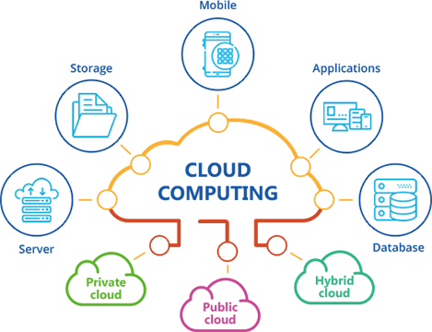

Fig [6] Cloud infrastructure

This image displays shows Cloud computing and how it is connected with mobile and applications etc.

### AWS

AWS have been the market leader in the web services and cloud computing industry nice the launch in 2006. AWS offers on-demand cloud computing platforms and APIs to individuals, companies, and governments, on a metered pay-as-you-go basis. [22] At the moment AWS provides 165 services from computing, storage, networking, database, analytics, application services, deployment, management, mobile, developer tools, and tools for the Internet of Things. [22] One of the more popular services are Amazon Elastic Compute Cloud (EC2) and Amazon Simple Storage Service (Amazon S3). This makes AWS a very smart option for this project. [22]

### Google cloud platform

In the early 2008 has Google developed its own Google Cloud (GCP). [23] GCP allows compatibility with MYSQL and PostgreSQL. Google Cloud SQL is a part of the Google Cloud Platform as well as G suit, enterprise versions of Android and Chrome OS, and APIs for machine learning and enterprise mapping services. [23] Google Cloud Platform runs entirely internally on the google service and is a platform as a service (PaaS). It runs on the same infrastructure as YouTube and Google Search. It is written in, and compatible with, Java, Go, C++, Ruby and Python. [23]

### Python Anywhere

Python Anywhere is a platform as a service (PaaS) that supports web applications written in python only. [24] Python anywhere provides in-browser access to server-based Python and Bash command-line interfaces along with a code editor with syntax highlighting. [24] Users are provided with a free hosting for one small web application. Python Anywhere has a fixed pricing plan. Python anywhere can be very fast for small simple applications but slower for some larger applications. PythonAnywhere is the simplest way to deploy python applications and also supports coding from iPad and other mobile devices. Common WSGI based web host are. [24 ]

* Django
* Flask
* Web2py

### Microsoft Azure

Microsoft Azure formerly known as Windows Azure is a cloud computing service which provide (PaaS) platform as a service, (SaaS) software as a service, (IaaS) infrastructure as a service which was created by Microsoft in2008.[25] Microsoft Azure is used worldwide in large companies and is second to AWS in the cloud providers rankings. It again offers services like building, testing, deploying, and managing applications with a focus on AI and machine learning. [25] One shortcoming of Azure is the lack of tutorials and learning materials available in comparison to AWS. Azure provide up to 600 service here are some of the more common one.

* Compute services
* Mobile services
* Storage service
* Data management
* Messaging
* Media service
* CDN (content delivery network)
* Developer
* management
* Machine learning
* Azure blockchain workbench
* Functions
* IOT

### Oracle Cloud

Oracle Cloud is a cloud computing service offered by Oracle Corporation provides servers, storage, network, applications and services through a global network of Oracle Corporation managed data centers. They provide similar services like AWS, Google cloud and Microsoft Azure. The company allows these services to be provisioned on demand over the Internet. [26]

Oracle Cloud provides (IaaS), (PaaS), (SaaS) and (DaaS). These services are created to build, deploy, integrate, and extend applications in the cloud. This platform supports several open standards (SQL, HTML5, REST, etc.). [26]

Oracle has branded its Infrastructure as a Service as Oracle Cloud Infrastructure (OCI). Here is what is provided in this service. [26]

**Infrastructure as a Service**

* Compute (provides vm instances)
* Storage (provides lots of types of storage)
* Networking (provides network with fully configurable IP addresses)
* Governance (provides Identity and Access Management)
* Database (provides a on demand db)
* Load Balancing (provides load balancing capability)
* Edge services (used to monitor the path between users and resources)
* Ravello (provides deployment of existing VMware or KVM based data center workloads)
* FastConnect (provides private connectivity across on-premises and cloud networks)

**Platform as a Service**

* Data management
* Application development
* Integration
* Business analytics
* Security
* Management
* Content and experice

**Software as a Service**

* Customer Experience (CX)
* Human Capital Management (HCM)
* Enterprise Resource Planning (ERP)
* Supply Chain Management (SCM)
* Enterprise Performance Management (EPM)
* Internet of Things Applications (IoT)
* SaaS Analytics
* Industry Solutions (Communications, Financial Services, Consumer Goods, High Tech and Manufacturing, Higher Education, Hospitality, Utilities)
* Deployment (adhering to standards for sectors such as Financial Services, Retail Services, Public Sector, U.S. Department of Defense Community)
* Block-Chain Cloud Service (in partnership with SAP, IBM and Microsoft)[10]
* Blockchain Applications

# Conclusion

While all the discussed technologies have their pros and cons and all would be in some way suitable for this project I will distinguish between them and pick a valid technology to use.

After application building research was done, I had an initial favourite technology that I think would stand out and I believed would suit my previous works from previous years. But first I will need to use a programming language to retrieve the data with C++ from the movesense sensors then use some sort of back-end service like AWS. I have never used this technology before, but the community of this technology seem to be very helpful and this technology is well document. The front-end technology that I will be using will be used is Xamarin as I always wanted this application to be cross platform and I believe Xamarin is one of the best cross platform tools. I compared all the Pros and Cons for Xamarin.Form and then made my discussion from that.

One of the reasons Xamarin was chosen was that is free for a project of the scale of the one that is being created. When we compared to similar technologies to Xamarin it was very clear that Xarmarin was a much more powerful and complete platform with much better tooling. Another big factor in picking Xamarin was that the app will have an attractive native look and feel which improves usability and a gives a great user experience making users more likely to keep using the it.

While there is pros there are also cons like the high learning curve to become very familiar with the technology. This is due to the developers having to become very familiar with the Xamarin.Forms and its architecture which will also need to be done when using new technologies. Also, if a developer has never used C# there will be a learning curve as well. But last year I has some experience using C# so I don’t think that should be a huge issue for the creation of this project. Another learning curve will be using XAML to create the UI as most people have never used that language and are more familiar with HTML, JS and CSS this might be an issue later down the road.

This application will be a cross-platform powerlifting wearable tracker that is targeted specifically at powerlifters and strength athletes. The target audience was very easy to pick as I and my friends training on strength improvement like how powerlifters would, however it was important that the application be suitable for all types of strength training not for just the elite powerlifters. The purpose of this application is to help athletes or users that wish to improve their strength training by analysing their main lifts and displaying valuable information like speed and power. I believe using these technologies will help create the best strength app possible.

# References & Fig

1. Nick (2018). Top 10 Wearable Technology Companies in the World 2018. [online] Technavio. Available at: https://blog.technavio.com/blog/top-10-wearable-technology-companies-worldwide [Accessed 31 Oct. 2019].
2. MOVESENSE SENSOR. (n.d.). [online] Available at: https://www.movesense.com/wp-content/uploads/2017/11/Movesense-Sensor-Datasheet-_-20171109.pdf [Accessed 31 Oct. 2019].
3. The Wearables For Good Challenge. (2015). Totem Open Health | Wearables For Good Challenge Finalist. [online] Available at: https://wearablesforgood.com/finalist-totem-open-health/ [Accessed 31 Oct. 2019].
4. Wikipedia Contributors (2019). Fitbit. [online] Wikipedia. Available at: https://en.wikipedia.org/wiki/Fitbit [Accessed 31 Oct. 2019].
5. Wikipedia Contributors (2019). Powerlifting. [online] Wikipedia. Available at: https://en.wikipedia.org/wiki/Powerlifting [Accessed 21 Apr. 2019].
6. ‌ Wikipedia Contributors (2019). Strength athletics. [online] Wikipedia. Available at: https://en.wikipedia.org/wiki/Strength_athletics [Accessed 31 Oct. 2019].
7. Wikipedia Contributors (2019). CrossFit. [online] Wikipedia. Available at: https://en.wikipedia.org/wiki/CrossFit [Accessed 31 Oct. 2019].
8. Wikipedia Contributors (2019). Suunto. [online] Wikipedia. Available at: https://en.wikipedia.org/wiki/Suunto [Accessed 31 Oct. 2019].
9. Suunto. (2019). Suunto sports watches with heart rate monitor and GPS. [online] Available at: https://www.suunto.com/en-ie/Product-search/See-all-Sports-Watches/ [Accessed 31 Oct. 2019].
10. Wikipedia Contributors (2019). Garmin. [online] Wikipedia. Available at: https://en.wikipedia.org/wiki/Garmin [Accessed 31 Oct. 2019].
11. Garmin.com. (2018). Fitness Watches | Smartwatches | GPS Sport Watches | Garmin. [online] Available at: https://buy.garmin.com/en-US/US/c10002-p1.html [Accessed 31 Oct. 2019].
12. Wikipedia Contributors (2019). Xamarin. [online] Wikipedia. Available at: https://en.wikipedia.org/wiki/Xamarin [Accessed 31 Oct. 2019].
13. AltexSoft. (2019). The Good and The Bad of Xamarin Mobile Development. [online] Available at: https://www.altexsoft.com/blog/mobile/pros-and-cons-of-xamarin-vs-native/ [Accessed 31 Oct. 2019].
14. Wikipedia Contributors (2019). Python (programming language). [online] Wikipedia. Available at: https://en.wikipedia.org/wiki/Python_(programming_language).
15. The C++ Programming Language. (2013). New Jersey: Pearson Education (Us.
16. Wikipedia Contributors (2019). C++. [online] Wikipedia. Available at: https://en.wikipedia.org/wiki/C%2B%2B [Accessed 31 Mar. 2019].
17. ‌Wikipedia Contributors (2019). Java (programming language). [online] Wikipedia. Available at: https://en.wikipedia.org/wiki/Java_(programming_language).
18. ByteScout. (2017). What is SQL and what is it used for. [online] Available at: https://bytescout.com/blog/what-is-sql-and-what-is-it-used-for.html [Accessed 31 Oct. 2019].
19. Wikipedia Contributors (2019). MySQL. [online] Wikipedia. Available at: https://en.wikipedia.org/wiki/MySQL.
20. Wikipedia Contributors (2019). NoSQL. [online] Wikipedia. Available at: https://en.wikipedia.org/wiki/NoSQL.
21. What is cloud infrastructure? - Definition from WhatIs.com (2017). What is cloud infrastructure? - Definition from WhatIs.com. [online] SearchCloudComputing. Available at: https://searchcloudcomputing.techtarget.com/definition/cloud-infrastructure [Accessed 31 Oct. 2019].
22. Wikipedia Contributors (2019). Google Cloud Platform. [online] Wikipedia. Available at: https://en.wikipedia.org/wiki/Google_Cloud_Platform [Accessed 31 Oct. 2019].
23. Wikipedia Contributors (2019). Amazon Web Services. [online] Wikipedia. Available at: https://en.wikipedia.org/wiki/Amazon_Web_Services.
24. Wikipedia Contributors (2019). PythonAnywhere. [online] Wikipedia. Available at: https://en.wikipedia.org/wiki/PythonAnywhere.
25. Wikipedia Contributors (2019). Microsoft Azure. [online] Wikipedia. Available at: https://en.wikipedia.org/wiki/Microsoft_Azure [Accessed 31 Oct. 2019].
26. Wikipedia Contributors (2019). Oracle Cloud. [online] Wikipedia. Available at: https://en.wikipedia.org/wiki/Oracle_Cloud [Accessed 31 Oct. 2019].
27. Beast Sensor. (2015). Beast sensor. [online] Available at: https://www.thisisbeast.com/en/product [Accessed 31 Oct. 2019].
28. Fitbit.com. (2014). Fitbit Charge 3 | Advanced Health and Fitness Tracker. [online] Available at: https://www.fitbit.com/ie/charge3 [Accessed 31 Oct. 2019].
29. Sawh, M. (2016). GymWatch review. [online] Wareable. Available at: https://www.wareable.com/fitness-trackers/gymwatch [Accessed 1 Nov. 2019].
30. Archive.org. (2013). Wayback Machine. [online] Available at: https://web.archive.org/web/20140726233631/http://www.usapowerlifting.com/wp-content/uploads/2014/02/USAPL-Rulebook-2013_1.pdf [Accessed 1 Nov. 2019].
31. Archive.org. (2011). Wayback Machine. [online] Available at: https://web.archive.org/web/20070929023106/http://www.powerlifting-ipf.com/IPF_rulebook_2007.pdf [Accessed 1 Nov. 2019].
32. PowerliftingToWin. (2012). Powerlifting Federations. [online] Available at: https://www.powerliftingtowin.com/powerlifting-federations/ [Accessed 1 Nov. 2019].
33. Fitbit.com. (2015). Fitbit, Inc. - IR Overview - Investor FAQ. [online] Available at: https://investor.fitbit.com/overview/investor-faq/default.aspx [Accessed 1 Nov. 2019].
34. Bell, K. (2014). Fitbit Updates App With Exercise and Run-Tracking Features. [online] Mashable. Available at: https://mashable.com/2014/06/25/fitbit-ios-update/?europe=true [Accessed 1 Nov. 2019].

**Fig**

1. <https://www.google.com/url?sa=i&source=images&cd=&cad=rja&uact=8&ved=2ahUKEwizl_n_rMHlAhWJasAKHa74CXIQjhx6BAgBEAI&url=https%3A%2F%2Fmobisoftinfotech.com%2Fresources%2Fblog%2Fwearable-technology-in-healthcare%2F&psig=AOvVaw2A6CeIz-xiWZn-LlSFnB96&ust=1572433823894540>

<https://www.google.com/url?sa=i&source=images&cd=&cad=rja&uact=8&ved=2ahUKEwiWoICZrcHlAhXLT8AKHQVODhQQjhx6BAgBEAI&url=https%3A%2F%2Fdatafloq.com%2Fread%2F3-major-challenges-facing-future-iot%2F2729&psig=AOvVaw0Z28VwGg31RtAaqw0vFeOB&ust=1572434512000080>

<https://www.google.com/url?sa=i&source=images&cd=&cad=rja&uact=8&ved=2ahUKEwi2nqO1z8HlAhU2QEEAHVMJDjgQjhx6BAgBEAI&url=https%3A%2F%2Fwww.castironstrength.com%2Fthe-best-fucking-12-weeks-of-powerlifting-youre-going-to-have-all-year%2F&psig=AOvVaw1EUnxYTM-fjIHYgo5MKf3B&ust=1572434723998562>

<https://www.google.com/url?sa=i&source=images&cd=&cad=rja&uact=8&ved=2ahUKEwjH-7brmcTlAhXCmFwKHSG7DV0Qjhx6BAgBEAI&url=https%3A%2F%2Fxamarinhelp.com%2Fxamarin-forms-making-traditional-xamarin-obsolete%2F&psig=AOvVaw2hB_Ph8ZLdAB2e93M_YDoF&ust=1572532370373167>

<https://www.google.com/url?sa=i&source=images&cd=&cad=rja&uact=8&ved=2ahUKEwjLxrqV98TlAhXKiFwKHQPsDh8Qjhx6BAgBEAI&url=https%3A%2F%2Fwww.industryconnect.org%2Fcommon-programming-languages%2F&psig=AOvVaw0Jt4UvxTN5gB_REPPtyTO1&ust=1572557389091279>

<https://www.google.com/url?sa=i&source=images&cd=&cad=rja&uact=8&ved=2ahUKEwiK05eo-8TlAhXJbsAKHQIlDckQjhx6BAgBEAI&url=https%3A%2F%2Fwww.konstantinfo.com%2Fblog%2Ffrontend-and-backend-web-development-all-you-need-to-know%2F&psig=AOvVaw2rOvvF-dD4LFdEwRMq4A0J&ust=1572558203642382>

1. <https://www.thisisbeast.com/en/product>
2. <https://www.fitbit.com/ie/charge3>
3. <https://www.wareable.com/fitness-trackers/gymwatch>